**A Project report on**

**VECTOR SPACE MODEL FILE SEARCH**

**Submitted in partial fulfillment of IV Semester, BCA, Mini project, related to Visual Programming [BCA403T] finalization**

**Bachelor of Computer Applications**

**Under**

**Bangalore North University, Karnataka**

**By**

**Pawan Kumar A [R1818835]**

**&**

**Natchapon Sirisorn [R1818833]**

**Under the guidance of**

**Dr. Krishnan R**

**Associate Professor  
Department of BCA  
Krupanidhi Degree College**



**Krupanidhi Degree College  
12/1, Chikka Bellandur,Carmelaram Post Varthur Hobli,**

**Off Sarjapur Road, Bangalore, Karnataka 560035**

**August 2019**

**KRUPANIDHI DEGREE COLLEGE**

**12/1, Chikka Bellandur,Carmelaram Post Varthur Hobli,**

**Off Sarjapur Road, Bangalore, Karnataka 560035**

**AFFILIATED TO BANGALORE NORTH UNIVERSITY, BANGALORE**

**APPROVED BY GOVT. OF KARNATAKA, ACCREDITED BY NAAC, NEW DELHI**

**DEPARTMENT OF BACHELOR OF COMPUTER APPLICATIONS**



**CERTIFICATE**

**This is to certify that the project entitled ‘VECTOR SPACE MODEL FILE SEARCH’ submitted in partial fulfillment of IV semester BCA, Mini project, related to the subject Visual Programming [BCA403T] of Bachelor of Computer Applications is a result of the work carried out by Pawan Kumar A [R1818835] & Natchapon Sirisorn [R1818833] during** **the** **academic year 2019-20 [Even Semester 2020]**

**Dr. Krishnan R Prof. Shubhi Srivasthava  
Course In- charge, Head of Department**

**Department of BCA Department of BCA**

**Krupanidhi Degree College Krupanidhi Degree College**

**Bangalore-35 Bangalore-35**

**Principal**

**Krupanidhi Degree College**

**UNDERTAKING BY THE STUDENTS**

We the students of IV Semester, **Pawan Kumar A [R1818835] & Natchapon Sirisorn [R1818833]** hereby declare that we have genuinely worked on the project titled **‘VECTOR SPACE MODEL FILE SEARCH’**

**Pawan Kumar A [R1818835]**

**Natchapon Sirisorn [R1818833]**

**ACKNOWLEDGMENT**

The satisfaction and euphoric that accompany the success of any work would be incomplete unless we mention the name of the people, who made it possible, whose constant guidance and encouragement served a beacon light and served our effort with success.

We are thankful to the head of the institution, **Dr. Badarunnisa S,  
Professor & Principal,** for providing an opportunity to do the project.

We are thankful to Prof. Shubhi Srivastava**,** HOD, BCA Department for being source of encouragement.

We express our sincere thanks and credit to our internal guide Dr. **Krishnan R**, Associate Professor, BCA Dept, KDC for his constant encouragement, support and guidance during the project work.

We are also thankful to all faculty of the department for their help and support during the project.

**Pawan Kumar A [R1818835]**

**Natchapon Sirisorn [R1818833]**

**TABLE OF CONTENTS**

**Particulars Page No**

1. Synopsis
   1. Objective….…………………………………………………………………… 1
   2. Project Concept….....…………………….…………………………………….. 1
   3. Tools Used..…………………………………………………….……………… 1
   4. Outcome of the Project………………………………………………………… 1
2. Project Concept
   1. Introduction..………………………………………………………………….. 2
   2. General Description …….…………………………………………...….......... 2
3. Project Logic Representation

3.1 Flow chart ……….……………………………………………………………5

1. Simulation Working & Source Code …………………………………………….6
   1. Working
   2. Source Code
2. Results and Conclusion………………………………………..………………...17
   1. Snap shots………………………………………………………..……………17
   2. Conclusion…………………………………………………………..………..17

6. Bibliography ………………………………………..………………...……………17

**Chapter 1: Synopsis**

* 1. **Objective**

To implement a basic search engine or document retrieval system using Vector space model. This use case is widely used in information retrieval systems. Given a set of documents and search term(s)/query we need to retrieve relevant documents that are similar to the search query.

* 1. **Project Concept**

[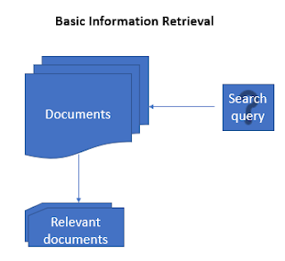](https://3.bp.blogspot.com/-w96aVPMy198/WfgQTqkmI7I/AAAAAAAAGAQ/zd3iZfVh0_E5Yy2d_1WSs5N8RB8rPJRbwCK4BGAYYCw/s1600/information%2Bretrieval_1.PNG)

Document retrieval system

Before we get into building the search engine, we will learn briefly about different concepts we use in this post: 

### ****Vector Space Model:****

A vector space model is an algebraic model, involving two steps, in first step we represent the text documents into vector of words and in second step we transform to numerical format so that we can apply any text mining techniques such as information retrieval, information extraction,information filtering etc.  
  
Let us understand with an example. consider below statements and a query term. The statements are referred as documents hereafter.

*Document 1: Cat runs behind rat*  
*Document 2: Dog runs behind cat*  
*Query: rat*

### ****Document vectors representation:****

In this step includes breaking each document into words, applying preprocessing steps such as removing stopwords, punctuations, special characters etc. After preprocessing the documents we represent them as vectors of words.   
Below is a sample representation of the document vectors.

1. *Document 1: (cat, runs, behind, rat)*  
   *Document 2: (Dog, runs, behind, cat)*  
   *Query: (rat)*

*the relevant document to Query = greater of (similarity score between (Document1, Query), similarity score between (Document2, Query)*

Next step is to represent the above created vectors of terms to numerical format known as term document matrix. 

### ****Term Document Matrix:****

A term document matrix is a way of representing documents vectors in a matrix format in which each row represents term vectors across all the documents and columns represent document vectors across all the terms. The cell values frequency counts of each term in corresponding document. If a term is present in a document, then the corresponding cell value contains 1 else if the term is not present in the document then the cell value contains 0.  
  
After creating the term document matrix, we will calculate term weights for all the terms in the matrix across all the documents. It is also important to calculate the term weightings because we need to find out terms which uniquely define a document.

1.3 Tools Used

Visual Studio VB Compiler for Implementation, MS Word for documentation

1.4 Outcome of the Project

Mathematically, closeness between two vectors is calculated by calculating the cosine angle between two vectors. In similar lines, we can calculate cosine angle between each document vector and the query vector to find its closeness. To find relevant document to the query term , we may calculate the similarity score between each document vector and the query term vector by applying cosine similarity . Finally, whichever documents having high similarity scores will be considered as relevant documents to the query term.  
  
When we plot the term document matrix, each document vector represents a point in the vector space. In the below example query, Document 1 and Document 2 represent 3 points in the vector space. We can now compare the query with each of the document by calculating the cosine angle between them.

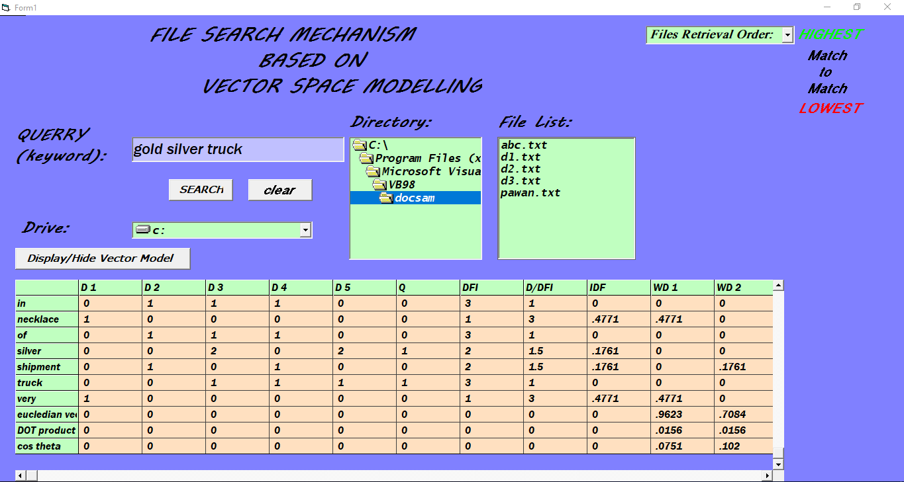

**2. Project Concept**

A term document matrix is a way of representing documents vectors in a matrix format in which each row represents term vectors across all the documents and columns represent document vectors across all the terms. The cell values frequency counts of each term in corresponding document. If a term is present in a document, then the corresponding cell value contains 1 else if the term is not present in the document then the cell value contains 0.  
  
After creating the term document matrix, we will calculate term weights for all the terms in the matrix across all the documents. It is also important to calculate the term weightings because we need to find out terms which uniquely define a document.   
  
We should note that a word which occurs in most of the documents might not contribute to represent the document relevance whereas less frequently occurred terms might define document relevance. This can be achieved using a method known as term frequency - inverse document frequency (tf-idf), which gives higher weights to the terms which occurs more in a document but rarely occurs in all other documents, lower weights to the terms which commonly occurs within and across all the documents.

**Tf-idf = tf X idf**  
*tf = term frequency is the number of times a term occurs in a document*  
*idf = inverse of the document frequency, given as below*  
*idf = log(N/df), where df is the document frequency-number of documents containing a term*

[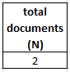](https://1.bp.blogspot.com/-mAM6NJ4bEoE/WfgfF2OfLII/AAAAAAAAGAs/axKBhPnJzR8W3QAEqNGf5ymiXpDg3JATgCK4BGAYYCw/s1600/information%2Bretrieval_3.PNG)

*total number of documents*

[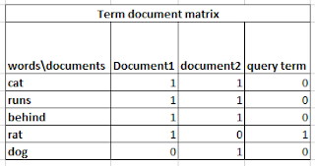](https://1.bp.blogspot.com/-crJGbyKFrVE/Wfgfhr3goWI/AAAAAAAAGA4/-s20-N7rNo44P_bTVeQ3idfSDR8byVyBwCK4BGAYYCw/s1600/information%2Bretrieval_term%2Bdocument%2Bmatrix.PNG)

*term document matrix*

[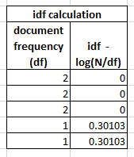](https://4.bp.blogspot.com/-tFQtMLUhGe4/Wfgf5itrTEI/AAAAAAAAGBA/W6YV8hXsI5QgHjIkwmjhLdQPnQyjh9iuQCK4BGAYYCw/s1600/information%2Bretrieval_inverse_document_frequency.PNG)

*inverse document frequency*

*Note: idf is calculated using logarithm of inverse fraction between document count and document frequency*

[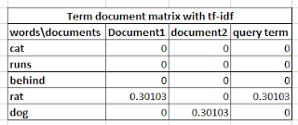](https://3.bp.blogspot.com/-dUNMClK9RkQ/WfggZdjH6dI/AAAAAAAAGBM/rC7SE_3fzLUjBFjwytpaGmPflFns8t3dwCK4BGAYYCw/s1600/tf_idf_term_document_matrix.PNG)

*tf-idf calculation*

*Note: Tf-idf weightage is calculated using tf X idf*

Note, there are many variations in the way we calculate the term-frequency(tf) and inverse document frequency (idf), in this post we have seen one variation. Below images show as the other recommended variations of tf and idf, taken from [wiki](https://en.wikipedia.org/wiki/Tf%E2%80%93idf).

[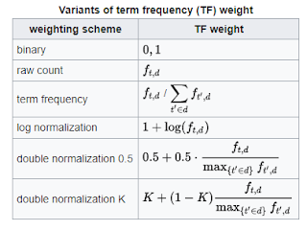](https://4.bp.blogspot.com/-iK-fPUBaCJw/WfquoRa2XSI/AAAAAAAAGCU/xISB9LksuyQBmMIIzLIbuJ-RhMob5WDRwCK4BGAYYCw/s1600/term_frequency_variants.PNG)

*term frequency variations*

[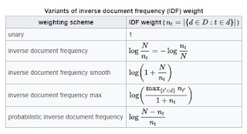](https://4.bp.blogspot.com/-YIotvRU0ObE/WfqvC548rPI/AAAAAAAAGCc/ewk6WlZ2zmUhp47xe3p8jKwvU6cyq12TACK4BGAYYCw/s1600/inverse_document_frequency_variants.PNG)

*inverse document frequency variations*

### ****Similarity Measures: cosine similarity****

Mathematically, closeness between two vectors is calculated by calculating the cosine angle between two vectors. In similar lines, we can calculate cosine angle between each document vector and the query vector to find its closeness. To find relevant document to the query term , we may calculate the similarity score between each document vector and the query term vector by applying cosine similarity . Finally, whichever documents having high similarity scores will be considered as relevant documents to the query term.  
  
When we plot the term document matrix, each document vector represents a point in the vector space. In the below example query, Document 1 and Document 2 represent 3 points in the vector space. We can now compare the query with each of the document by calculating the cosine angle between them.

[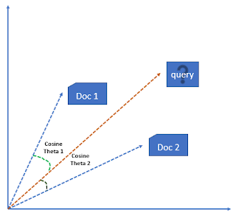](https://2.bp.blogspot.com/-saTZSoc5RAA/WfghS_CMvJI/AAAAAAAAGBg/PcZvT0QNZCcPJq8fAv2v_cSwrnagdm9RgCK4BGAYYCw/s1600/cosine_similarity.PNG)

*cosine similarity*

Apart from cosine similarity, we have other variants for calculating the similarity scores and are shown below:

* Jaccard distance
* Kullback-Leibler divergence
* Euclidean distance

1. **Project Logic Representation**

* Load documents and search queries into the R programming environment as list objects.
* Preprocess the data by creating a corpus object with all the documents and query terms, removing stop words, punctuations using tm package.

[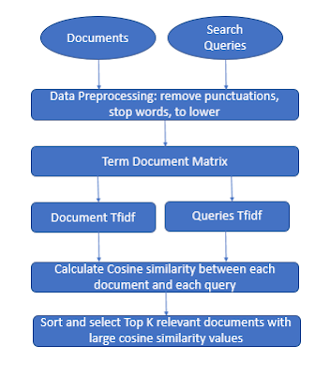](https://3.bp.blogspot.com/-Ix9pGH_mYNM/Wfgm064NpqI/AAAAAAAAGCA/X-P4V2917Pgr5hPnRVvRkfRD6GwgjL1rACK4BGAYYCw/s1600/information%2Bretrieval_2.PNG)

*high level information retrieval system*

* Creating a term document matrix with tf-idf weight setting available in TermDocumentMatrix() method.
* Separate the term document matrix into two parts- one containing all the documents with term weights and other containing all the queries with term weights.
* Now calculate cosine similarity between each document and each query.
* For each query sort the cosine similarity scores for all the documents and take top-3 documents having high scores.

**Step 1:**

Set up file retrieval using file list box, directory list box, and drive list box

**Step 2:**

Set up query retrieval text box for user input.

**Step 3:**

Implement split() function on the query and the selected directory files content to retrieve individual words of each file content.

**Step 4:**

Implement redundancy removal to filter duplicate words from the above steps.

**Step 5:**

1. Read File Content and Querry

Invoke Call ReadDataAndQuerry

2. get all the collection of document strings in final text

Invoke Call ConcatFile

3. initialisations

donelen = arrlen = qrylen = 0

4. split(finaltext," ") and get length of splitted string

Invoke Call wordsintext(finaltext, arr, arrlen)

5. split(querry," ") and get length of splitted string

Invoke Call wordsintext(qry, querry, qrylen)

6. sort in alphabetic order A - Z

Invoke Call sort(arr, arrlen)

Call sort(querry, qrylen)

7. Remove redundancy of duplicate words in split array

Invoke Call remduplication(done, donelen, arr, arrlen)

8. quantify terms frequency

Invoke Call termfrequency

9. calculate the document frequency

Invoke Call CalcDFI

10. calculate the document frequency ratio to number of documents

Invoke Call CalcDDFI

11. calculate the IDF Value

Invoke Call CalcIDF

12. calculate the weights of each document Corresponding to the querry

Invoke Call Calcweights

13. Table Orientation of Vector Space Model Matrix

Invoke Call TableOrientation

14. Calculate euclidean length of vector

Invoke Call euclideanvector

15. Calculate Dot vector Values

Invoke Call DotProduct

16. Calculate Cosine Values To determine highest match

Invoke Call CalcCOS

17. Print Vector Model Data into Table Matrix

Invoke Call PrintData

18. File Retrieval Order

Invoke Call FileRetrieve

**4. Source Code**

Dim k As Integer 'local

Dim kp As Integer 'display and hide

Dim qry As String 'querry string

Dim finaltext As String 'collection of all document text

Dim donelen As Integer 'Non repeated words length

Dim arrlen As Integer 'collection of split words in final text

Dim qrylen As Integer 'split words length in querry

Dim terms(1000, 1000) As Double 'table of vector model

Dim arr(10000) As String 'split words of final text

Dim querry(100) As String 'split words of querry

Dim done(10000) As String 'split words of non repeated array

Dim fle(10000, 10000) As String 'file related

Dim flen(10000) As Integer 'file related

Dim filecontent(10000) As String 'file related

Dim rowlen As Integer 'Total columns in matrix

Private Sub Command1_Click()

Dim i As Integer

Dim j As Integer

'1. Read File Content and Querry

Call ReadDataAndQuerry

'2. get all the collection of document strings in final text

Call ConcatFile

'3. initialisations

donelen = arrlen = qrylen = 0

'4. split(finaltext," ") and get length of splitted string

Call wordsintext(finaltext, arr, arrlen)

'5. split(querry," ") and get length of splitted string

Call wordsintext(qry, querry, qrylen)

'6. sort in alphabetic order A - Z

Call sort(arr, arrlen)

Call sort(querry, qrylen)

'7. Remove redundancy of duplicate words in split array

Call remduplication(done, donelen, arr, arrlen)

'8. quantify terms frequency

Call termfrequency

'9. calculate the document frequency

Call CalcDFI

'10. calculate the document frequency ratio to number of documents

Call CalcDDFI

'11. calculate the IDF Value

Call CalcIDF

'12. calculate the weights of each document Corresponding to the querry

Call Calcweights

'13. Table Orientation of Vector Space Model Matrix

Call TableOrientation

'14. Calculate euclidean length of vector

Call euclideanvector

'15. Calculate Dot vector Values

Call DotProduct

'16. Calculate Cosine Values To determine highest match

Call CalcCOS

'17. Print Vector Model Data into Table Matrix

Call PrintData

'18. File Retrieval Order

Call FileRetrieve

End Sub

Private Sub Command2_Click()

Text6.text = ""

End Sub

Private Sub Command3_Click()

'MsgBox (kp)

If kp = 0 Then

table.Visible = True

kp = 1

Else

table.Visible = False

kp = 0

End If

End Sub

Private Sub Dir1_Change()

File1.Path = Dir1.Path

End Sub

Private Sub Drive1_Change()

Dir1.Path = Drive1.Drive

End Sub

Public Sub wordsintext(text As String, ByRef arr() As String, ByRef n As Integer)

Dim ln As Integer

Dim i As Integer

Dim j As Integer

i = 1

j = 0

text = Trim(text)

ln = Len(text)

Dim cnt As Integer

cnt = 0

Do While i <= ln

Dim ch As String

ch = Mid(text, i, 1)

If ch <> " " And ch <> "." Then

cnt = cnt + 1

Else

If Mid(text, i - cnt, cnt) <> "" And Mid(text, i - cnt, cnt) <> " " And Mid(text, i - cnt, cnt) <> " " Then

arr(j) = Mid(text, i - cnt, cnt)

j = j + 1

cnt = 0

End If

End If

i = i + 1

Loop

If Mid(text, i - cnt, cnt) <> "" And Mid(text, i - cnt, cnt) <> " " And Mid(text, i - cnt, cnt) <> " " Then

arr(j) = Mid(text, i - cnt, cnt)

End If

n = j

End Sub

Public Sub wordsintext1(text As String, ByVal k As Integer, ByRef n As Integer)

Dim ln As Integer

Dim i As Integer

Dim j As Integer

i = 1

j = 0

text = Trim(text)

ln = Len(text)

Dim cnt As Integer

cnt = 0

Do While i <= ln

Dim ch As String

ch = Mid(text, i, 1)

If ch <> " " And ch <> "." Then

cnt = cnt + 1

Else

If Mid(text, i - cnt, cnt) <> "" And Mid(text, i - cnt, cnt) <> " " And Mid(text, i - cnt, cnt) <> " " Then

fle(k, j) = Mid(text, i - cnt, cnt)

j = j + 1

cnt = 0

End If

End If

i = i + 1

Loop

If Mid(text, i - cnt, cnt) <> "" And Mid(text, i - cnt, cnt) <> " " And Mid(text, i - cnt, cnt) <> " " Then

fle(k, j) = Mid(text, i - cnt, cnt)

End If

n = j

End Sub

Public Sub sort(ByRef arr() As String, n As Integer)

Dim i As Integer

Dim j As Integer

For i = 0 To n - 1

For j = 0 To n - i - 1

If arr(j) <> "" And arr(j) <> " " And arr(j) <> " " And arr(j + 1) <> "" And arr(j + 1) <> " " And arr(j + 1) <> " " Then

If Len(arr(j)) > Len(arr(j + 1)) Then

Dim temp As String

temp = arr(j)

arr(j) = arr(j + 1)

arr(j + 1) = temp

End If

End If

Next j

Next i

For i = 0 To n - 1

For j = 0 To n - i - 1

If arr(j) <> "" And arr(j) <> " " And arr(j) <> " " And arr(j + 1) <> "" And arr(j + 1) <> " " And arr(j + 1) <> " " Then

If Asc(arr(j)) > Asc(arr(j + 1)) Then

temp = arr(j)

arr(j) = arr(j + 1)

arr(j + 1) = temp

End If

End If

Next j

Next i

End Sub

Public Sub remduplication(ByRef done() As String, ByRef j As Integer, arr() As String, n As Integer)

Dim i As Integer

For i = 0 To n

If i = 0 Then

j = 0

done(j) = arr(i)

j = j + 1

End If ' a a b c c d e f f

Dim k As Integer

For k = 0 To j

If arr(i) = done(k) Then

Exit For

End If

Next k

If k = j + 1 Then

done(j) = arr(i)

j = j + 1

End If

Next i

End Sub

Public Sub termfrequency()

Dim i As Integer

Dim j As Integer

For i = 0 To donelen - 1

For j = 0 To File1.ListCount - 1

Dim k As Integer

For k = 0 To flen(j)

If done(i) = fle(j, k) Then

terms(i, j) = terms(i, j) + 1

End If

Next k

Next j

If j = File1.ListCount Then

For k = 0 To qrylen

If done(i) = querry(k) Then

terms(i, j) = terms(i, j) + 1

End If

Next k

End If

Next i

End Sub

Public Sub sortnum(ByRef ar() As Double, n As Integer, ByRef cos() As String)

Dim temp As String

Dim tempk As Double

For i = 0 To n - 2

For j = 0 To n - i - 2

If ar(j) < ar(j + 1) Then

temp = cos(j)

cos(j) = cos(j + 1)

cos(j + 1) = temp

tempk = ar(j)

ar(j) = ar(j + 1)

ar(j + 1) = tempk

End If

Next j

Next i

End Sub

Private Sub Form_Load()

File1.Path = "C:\Program Files (x86)\Microsoft Visual Studio\VB98\docsam"

Dir1.Path = "C:\Program Files (x86)\Microsoft Visual Studio\VB98\docsam"

table.Visible = False

kp = 0

End Sub

Public Sub CalcDFI()

Dim i As Integer

Dim j As Integer

For i = 0 To donelen - 1 'DFI

terms(i, File1.ListCount + 1) = 0

For j = 0 To File1.ListCount - 1

If terms(i, j) <> 0 Then

terms(i, File1.ListCount + 1) = terms(i, File1.ListCount + 1) + 1

End If

Next j

Next i

End Sub

Public Sub CalcDDFI()

Dim i As Integer

For i = 0 To donelen - 1 'D/DFI D:no of documents 3

terms(i, File1.ListCount + 2) = Round(3 / terms(i, File1.ListCount + 1), 2)

Next i

End Sub

Public Sub CalcIDF()

Dim i As Integer

For i = 0 To donelen - 1 'IDF = Log(D/dfi)

terms(i, File1.ListCount + 3) = Round(Log(terms(i, File1.ListCount + 2)) / Log(10), 4)

Next i

End Sub

Public Sub Calcweights()

Dim i As Integer

Dim j As Integer

rowlen = ((File1.ListCount + 1) * 2) + 3

For i = 0 To donelen - 1

For j = File1.ListCount + 4 To rowlen - 1

terms(i, j) = Round(terms(i, j - 4 - File1.ListCount) * terms(i, File1.ListCount + 3), 4)

Next j

Next i

End Sub

Public Sub TableOrientation()

Dim i As Integer

Dim j As Integer

table.Rows = donelen + 4

table.Cols = rowlen + 1

table.TextMatrix(0, 0) = " "

For j = 1 To File1.ListCount

table.TextMatrix(0, j) = "D" + Str(j)

Next j

table.TextMatrix(0, File1.ListCount + 1) = "Q"

table.TextMatrix(0, File1.ListCount + 2) = "DFI"

table.TextMatrix(0, File1.ListCount + 3) = "D/DFI"

table.TextMatrix(0, File1.ListCount + 4) = "IDF"

i = 1

For j = File1.ListCount + 5 To rowlen - 1

table.TextMatrix(0, j) = "WD" + Str(i)

i = i + 1

Next j

table.TextMatrix(0, rowlen) = "WDQ"

For i = 1 To donelen

table.TextMatrix(i, 0) = done(i - 1)

Next i

table.TextMatrix(donelen + 1, 0) = "eucledian vector"

table.TextMatrix(donelen + 2, 0) = "DOT product"

table.TextMatrix(donelen + 3, 0) = "cos theta"

End Sub

Public Sub euclideanvector()

Dim i As Integer

Dim j As Integer

For j = File1.ListCount + 4 To rowlen - 1

terms(donelen, j) = 0

For i = 0 To donelen - 1

terms(donelen, j) = Round(terms(donelen, j) + (terms(i, j) ^ 2), 4)

Next i

terms(donelen, j) = Round(Sqr(terms(donelen, j)), 4)

Next j

End Sub

Public Sub DotProduct()

Dim i As Integer

Dim j As Integer

For j = File1.ListCount + 4 To rowlen - 2

terms(donelen + 1, j) = 0

For i = 0 To donelen - 1

terms(donelen + 1, j) = terms(donelen + 1, j) + terms(i, j) * terms(i, rowlen - 1)

Next i

terms(donelen + 1, j) = Round(terms(donelen + 1, j), 4)

Next j

End Sub

Public Sub CalcCOS()

Dim j As Integer

For j = File1.ListCount + 4 To rowlen - 2

terms(donelen + 2, j) = Round(terms(donelen + 1, j) / (terms(donelen, rowlen - 1) * terms(donelen, j)), 4)

Next j

End Sub

Public Sub PrintData()

Dim i As Integer

Dim j As Integer

For i = 1 To donelen + 3

For j = 1 To rowlen

table.TextMatrix(i, j) = Str(terms(i - 1, j - 1))

Next j

Next i

End Sub

Public Sub FileRetrieve()

Dim i As Integer

Dim j As Integer

Dim cosval(10000) As Double

Dim cosstring(10000) As String

i = 0

For j = File1.ListCount + 4 To rowlen - 2

cosval(i) = terms(donelen + 2, j)

cosstring(i) = table.TextMatrix(0, j + 1)

i = i + 1

Next j

Call sortnum(cosval, File1.ListCount, cosstring)

For i = 0 To File1.ListCount - 1

Dim y As Integer

y = Val(Mid(cosstring(i), 4, 1))

Combo1.AddItem File1.List(y - 1), i

Next i

End Sub

Public Sub ConcatFile()

Dim i As Integer

For i = 0 To File1.ListCount - 1

finaltext = finaltext + filecontent(i) + " "

Next i

End Sub

Public Sub ReadDataAndQuerry()

Dim i As Integer

For i = 0 To File1.ListCount - 1

Dim strFile As String

'With CD

' .ShowOpen

' Text1.Text = .FileName

'End With

Open File1.Path + "\" + File1.List(i) For Input As #1

Do While Not (EOF(1))

Line Input #1, strFile

filecontent(i) = filecontent(i) + " " + strFile

Loop

Call wordsintext1(filecontent(i), i, flen(i))

Close #1

Next i

qry = Text6.text

End Sub

**Output**

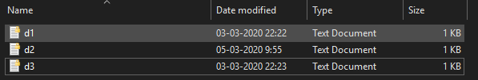

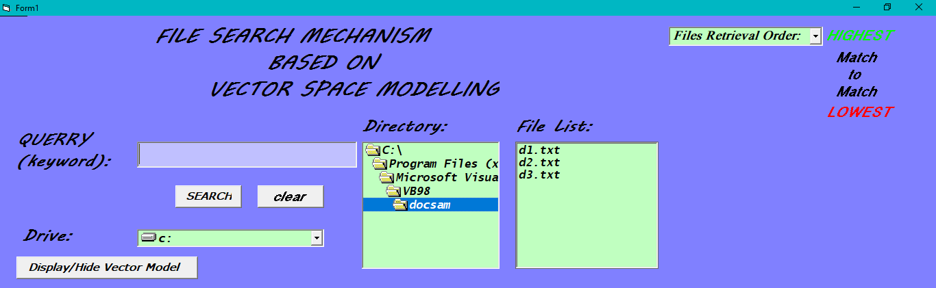

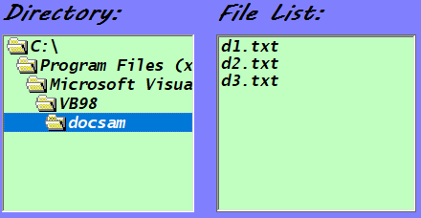

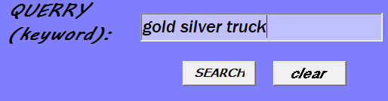

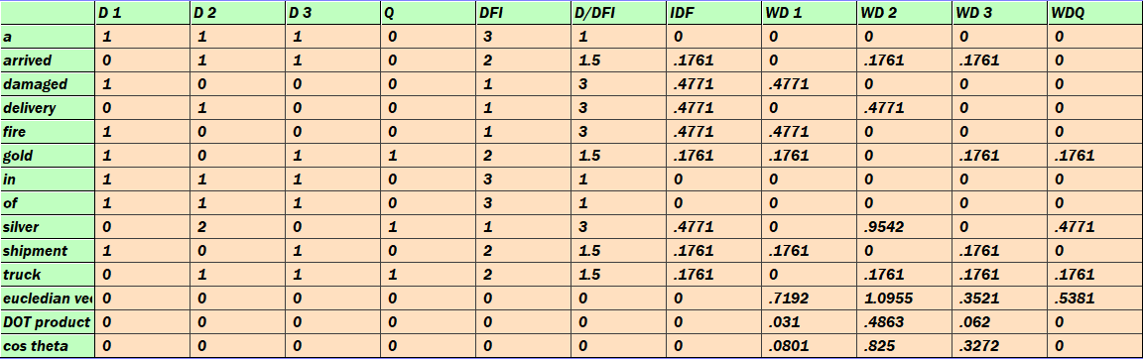

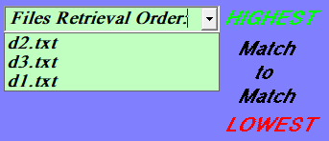

## Conclusion

The project entitled ‘**VECTOR SPACE MODEL FILE SEARCH**’ is completed successfully with the collective effort of both involved in the project. The project has successfully overcome all the errors pertaining in the existed system. With the help of this project,

* We can retrieve files based on key query
* Efficient search engines for files , items or objects in various fields
* Order of retrieval emanates a sequence of a number of possible files and items to select from.
* Allows documents with partial match to be also included.
* The cosine formula gives a score which can be used to order documents.

The overall goal of the field of Visual Programming is achieved, and same implementation techniques can be used in other programming projects.

## Bibliography